Customer Interface Testing and Evaluation

1. Customer Login and Registration

To login the Customer Interface you will register the account

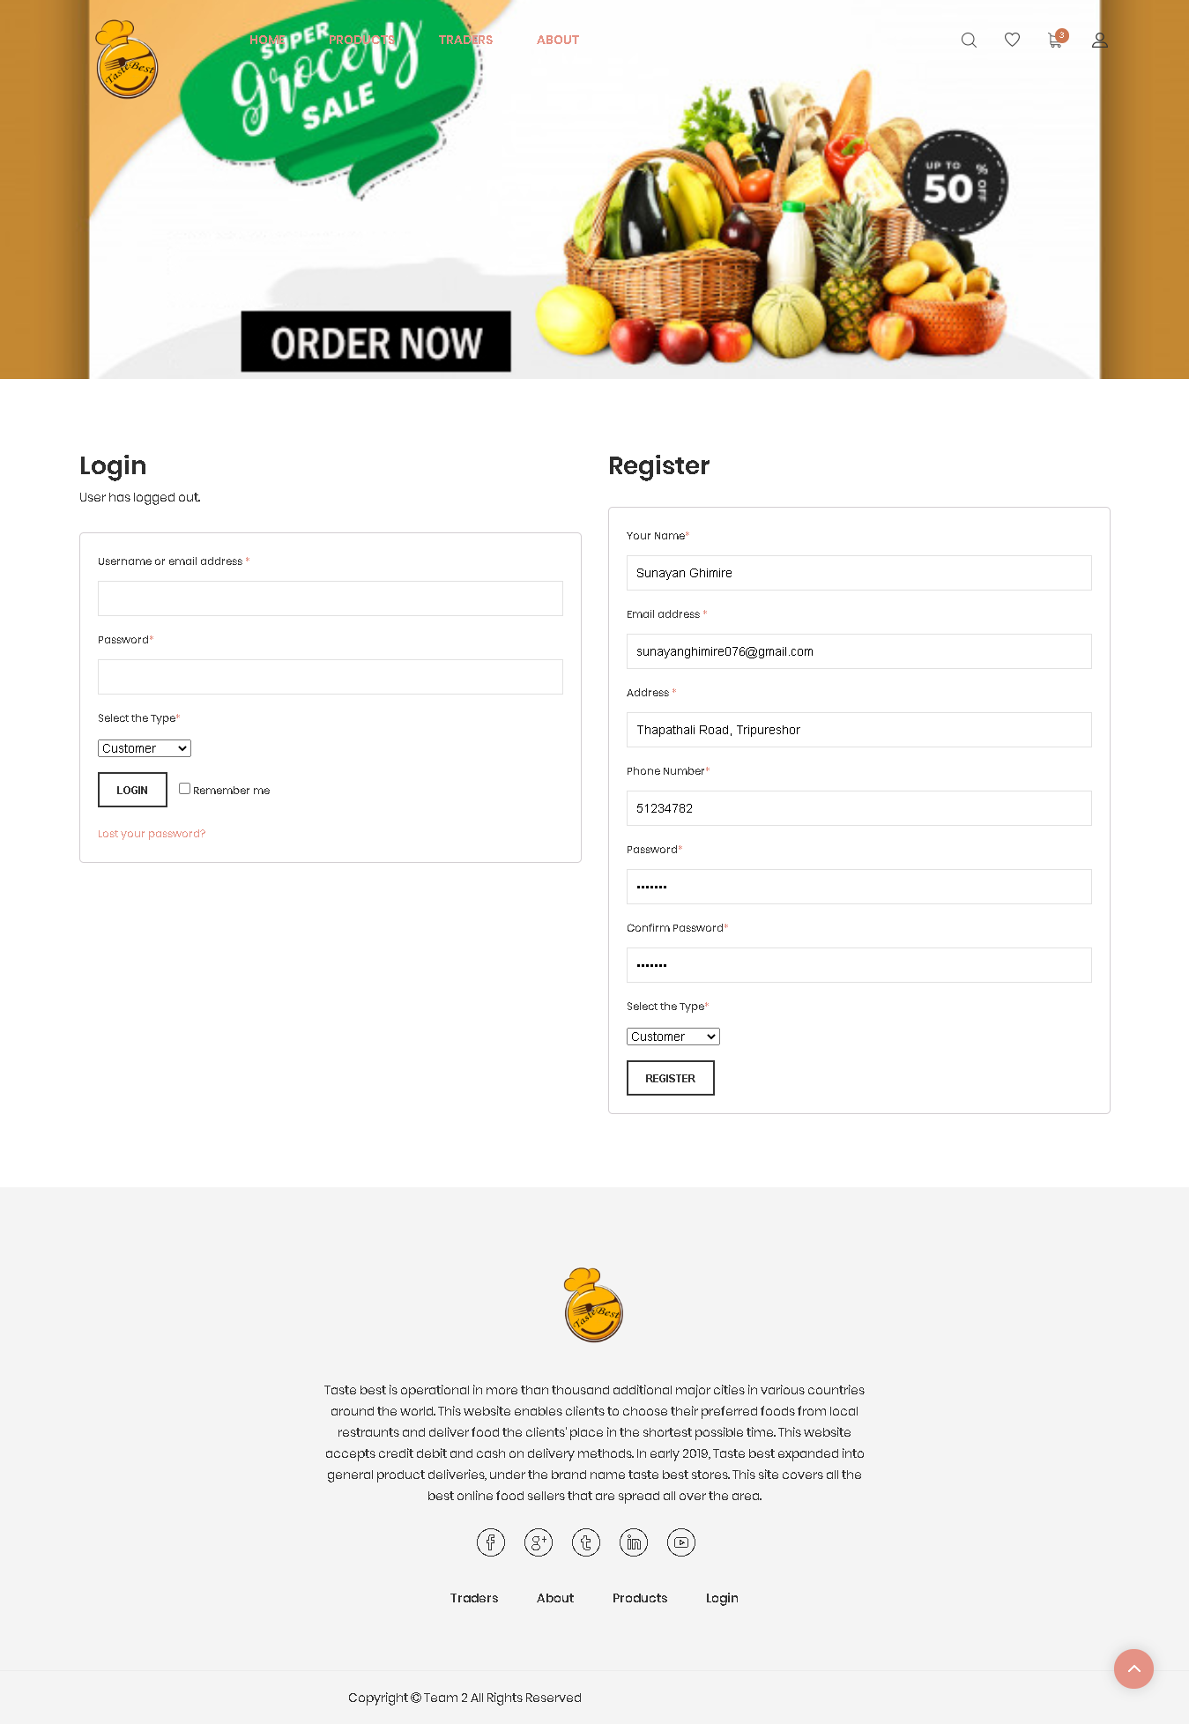

2. Register with empty fields

Fill out all the valid credentials

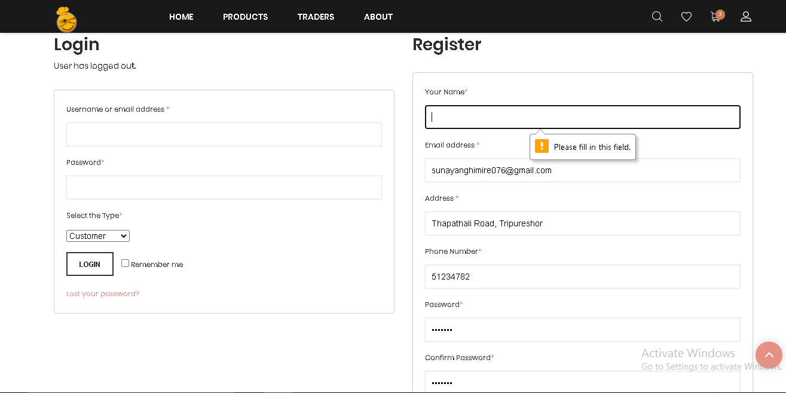

3. Password and Confirm Password Not Match

‘Password didn’t match’ if the confirm passwords don’t match.

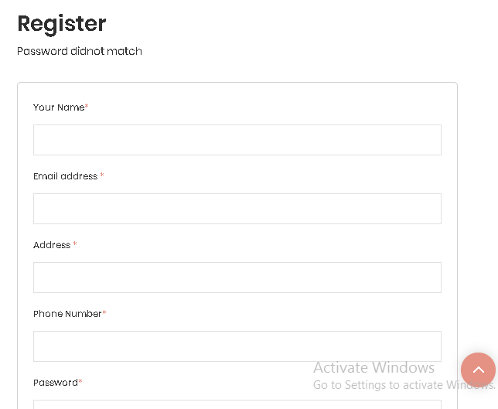

4. If Email is Already in use

If the email is already used than it display error message that the ‘Email is taken already. Please use another Email Address’.

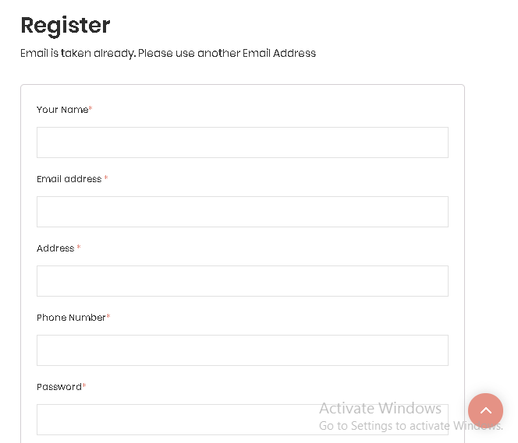

5. Registration Approved

Now the email has been successfully registered so we check our email for OTP.

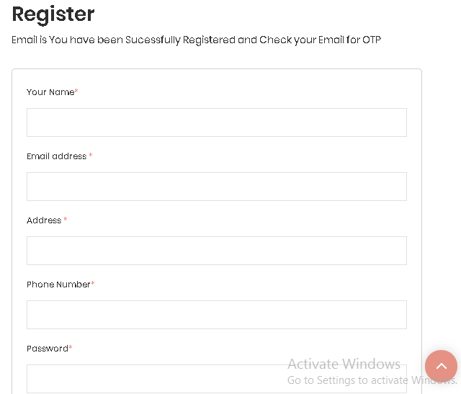

6. Login with Empty Fields

Enter valid credentials for logging in

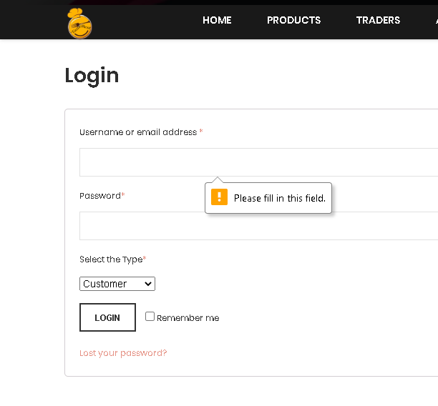

7. Login with Invalid Email or Username

Invalid Username is displayed if the username and email is invalid.

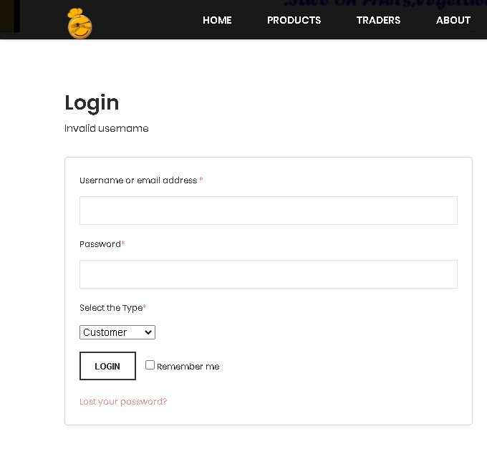

8. Login with Invalid Password

Invalid password is displayed if password is incorrect

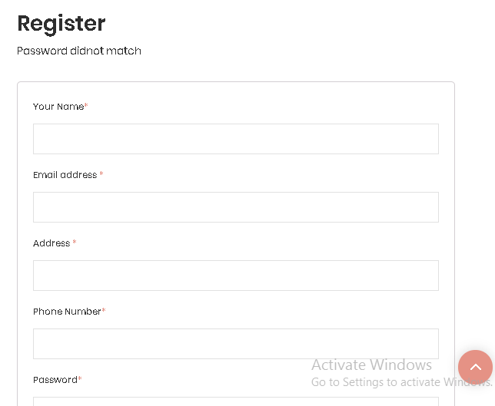

10. After login you are redirect to website home page

Now Customer login with valid credentials. Login Success.

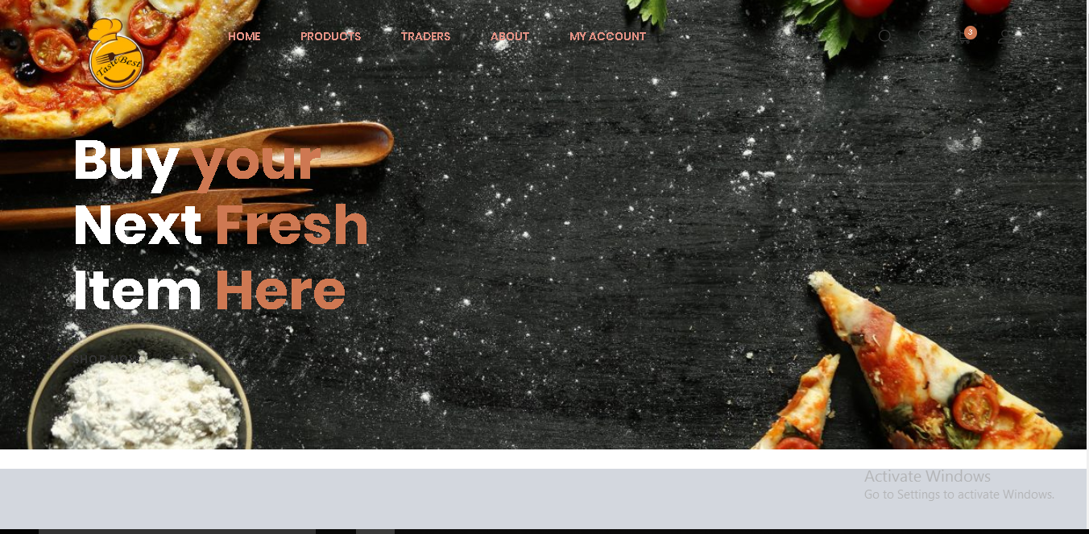

11. Slider button leads to next background

At the left side of the corner there is slider button which you can slides leads to the next background.

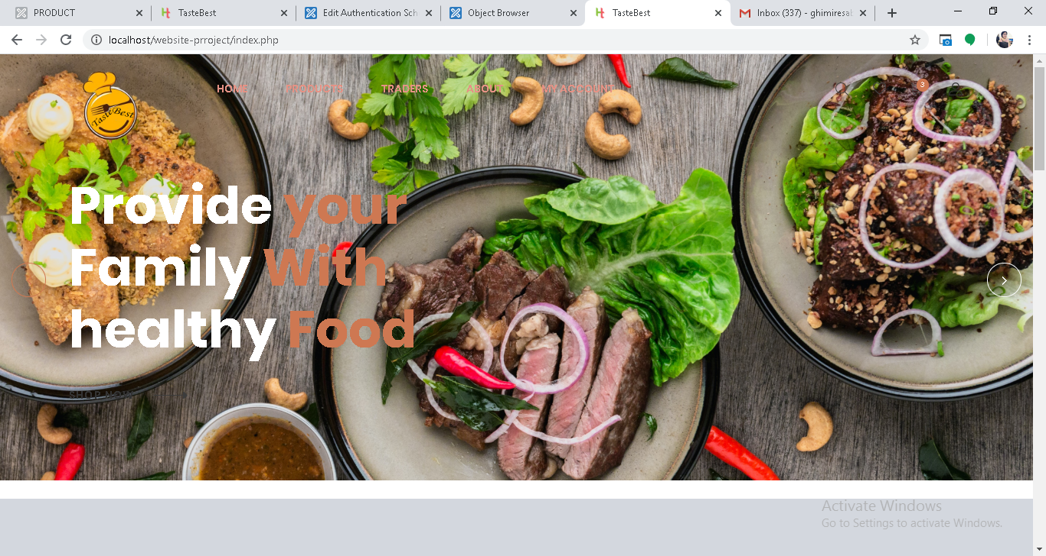

12. Product Display in Home Page

When you click on the products page at the top of the homepage you can see all the products displayed in homepage.

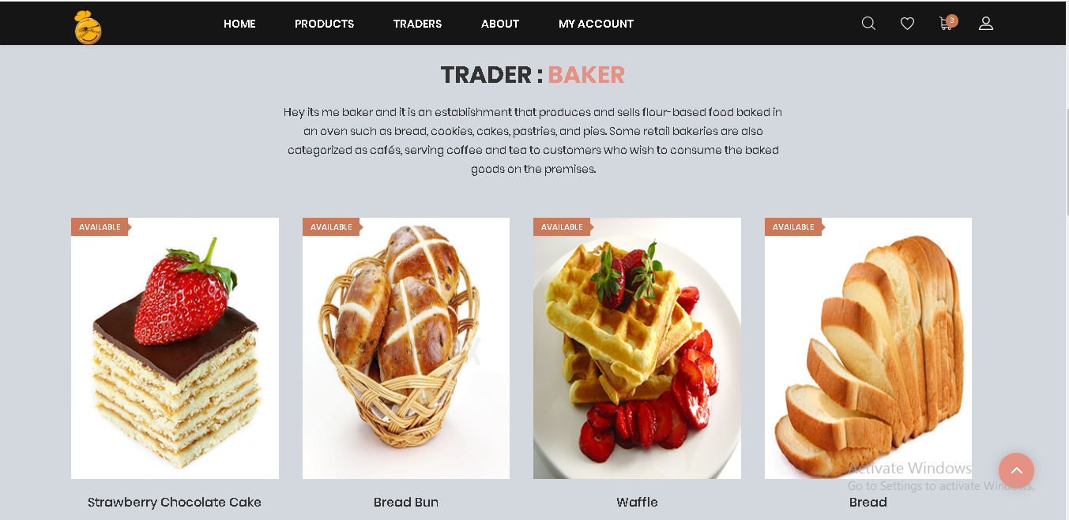

13. Random display of product and banner each time you load the page

Once to load the page each and every time it will random display of product and banner.

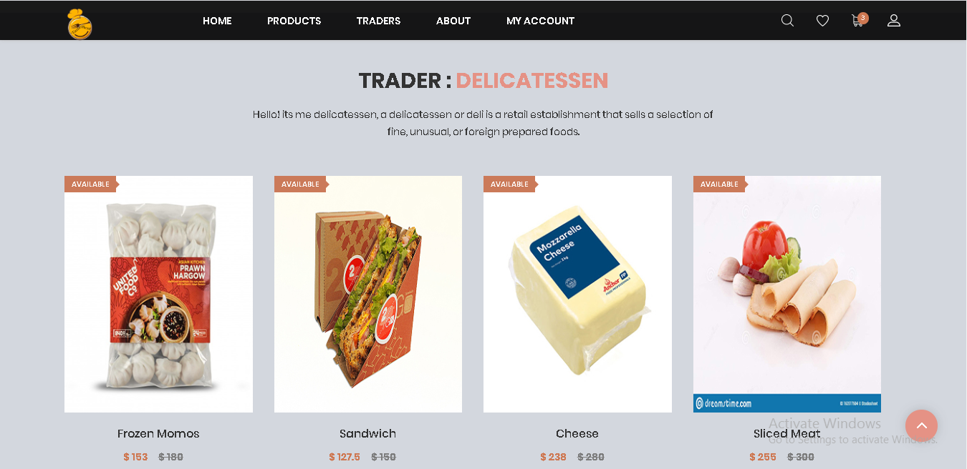

14. Button that helps to view other products in home page

Once you click the chevron right button it helps to view other products in home page.

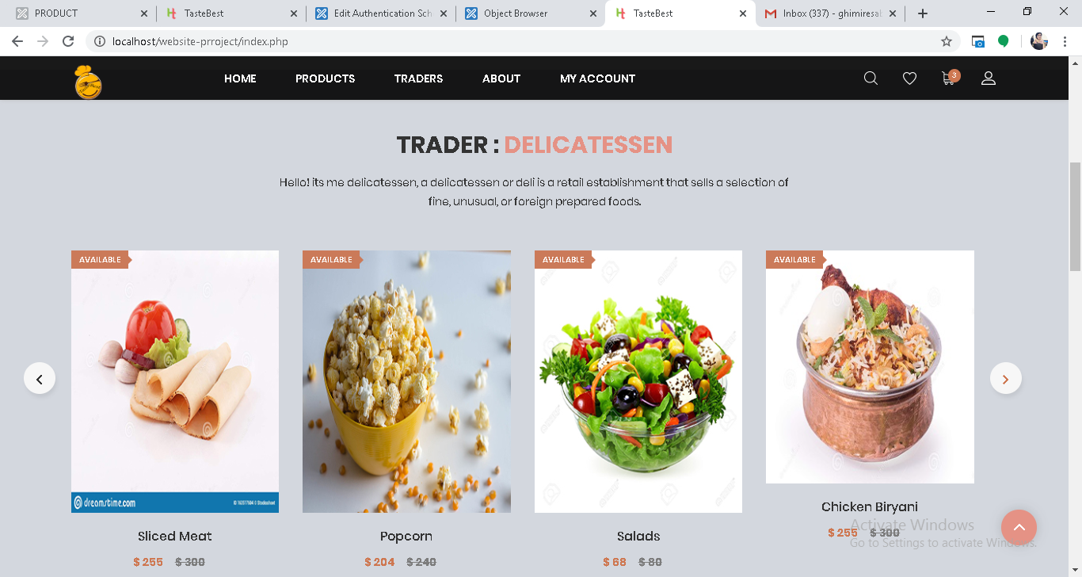

15. Hover over product and you can see shop and product categories accordingly you can sort the product on the basis of shop and categories.

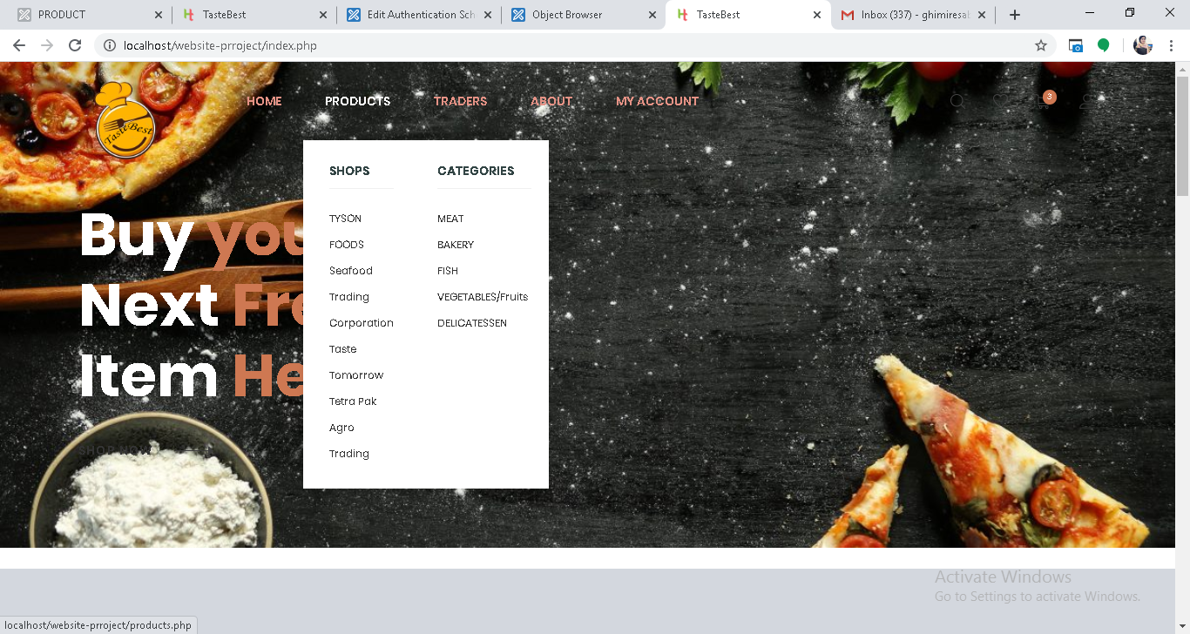

16. Product Page

Click on product categories and shop categories drop down you can see the different products so you can buy the products by shop categories which helps to buy products easily.

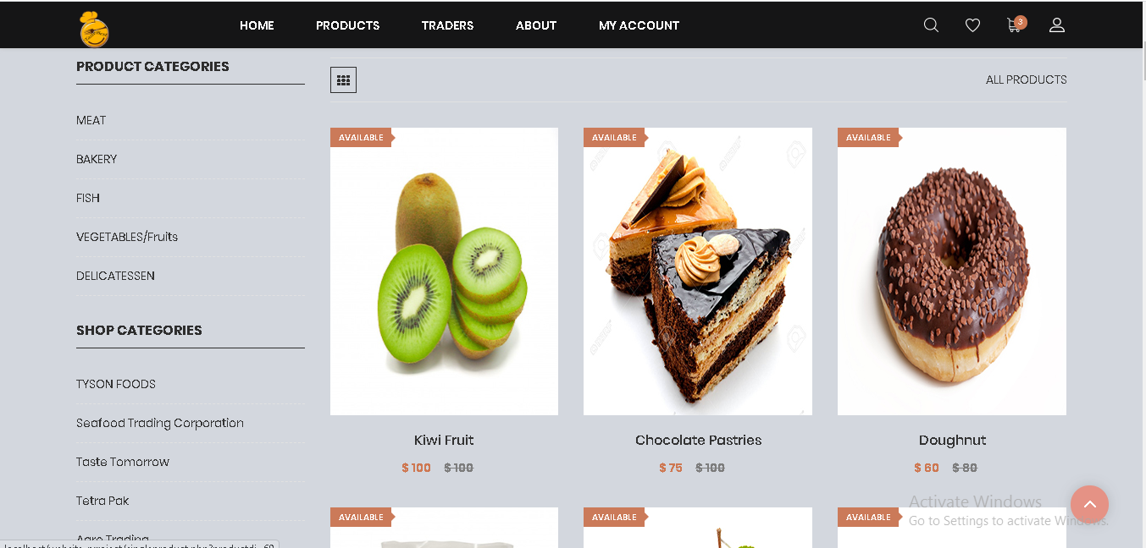

17. Sort according to product category meat and we can sort in same way with other product categories and buy the product of respective category.

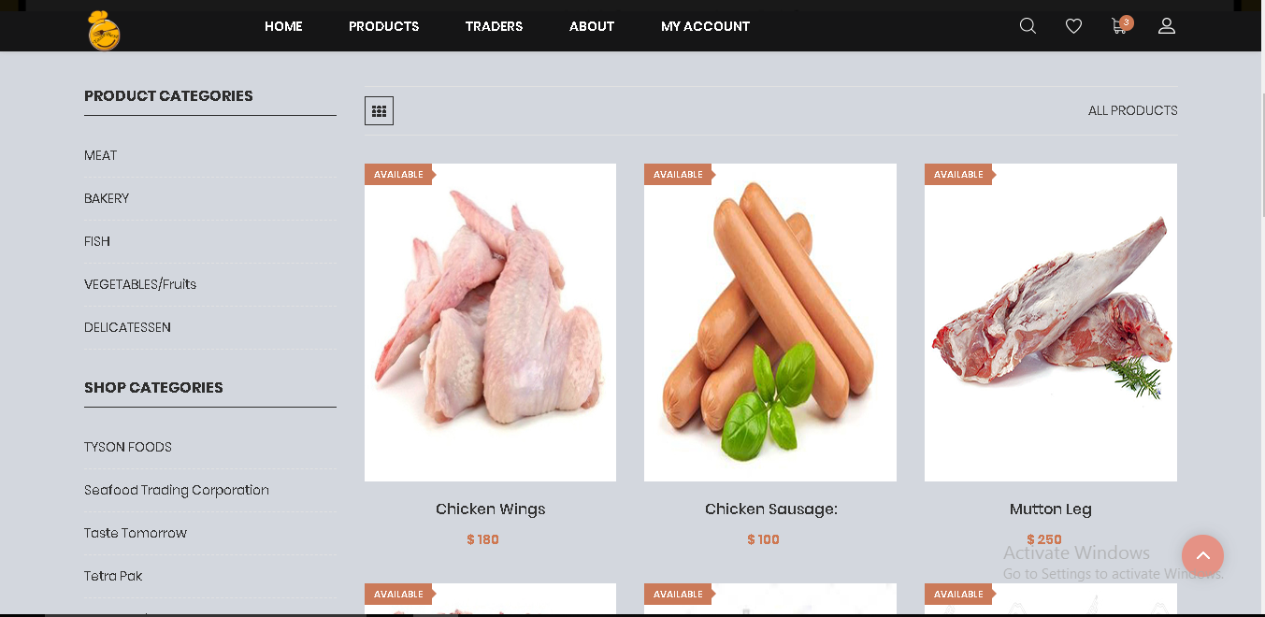

Only Item of Meat category Available.

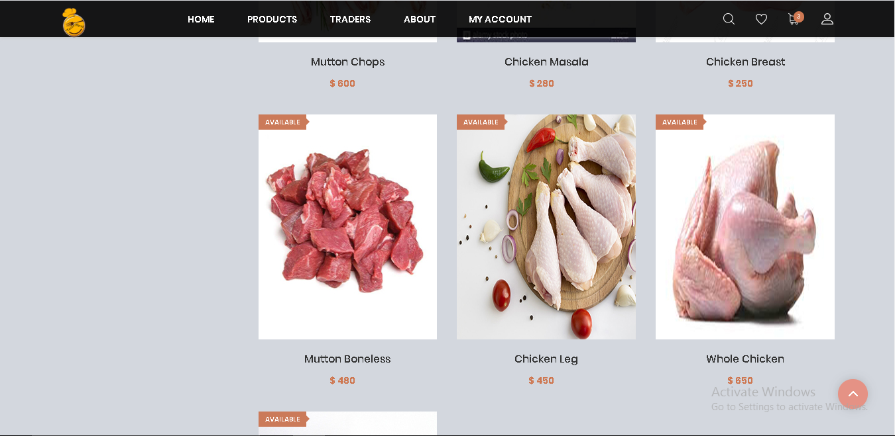

18. Sort according to shop Taste tomorrow and we can sort in same way with other shop categories of five trader and buy the product of respective shop category

Only Item of Taste Tomorrow category Available

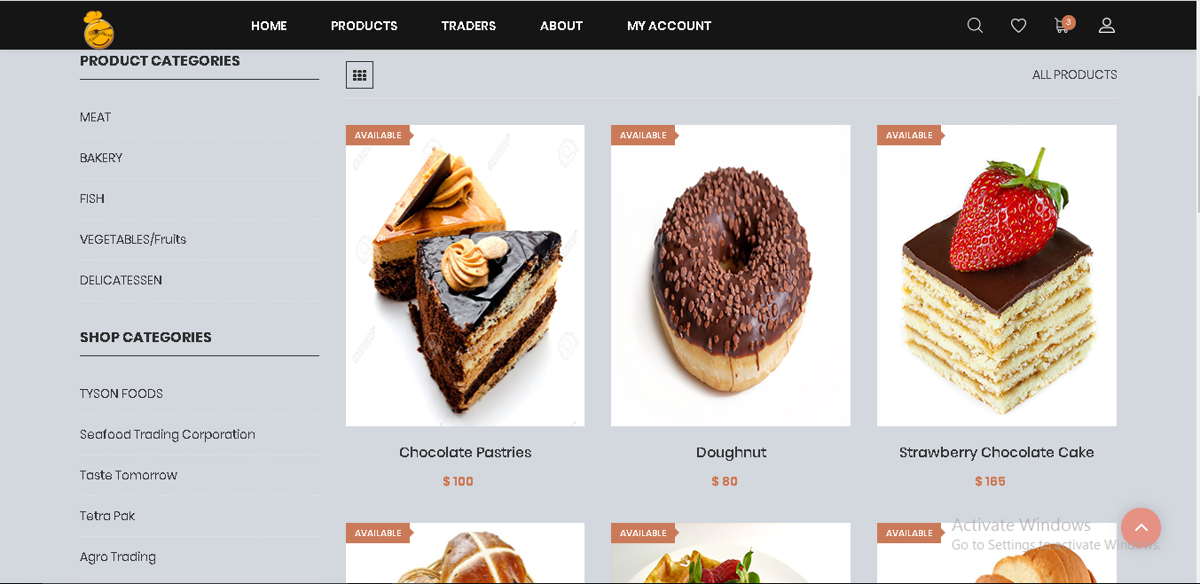

19. Search product

You can search the respective product by clicking search icon on the navbar.

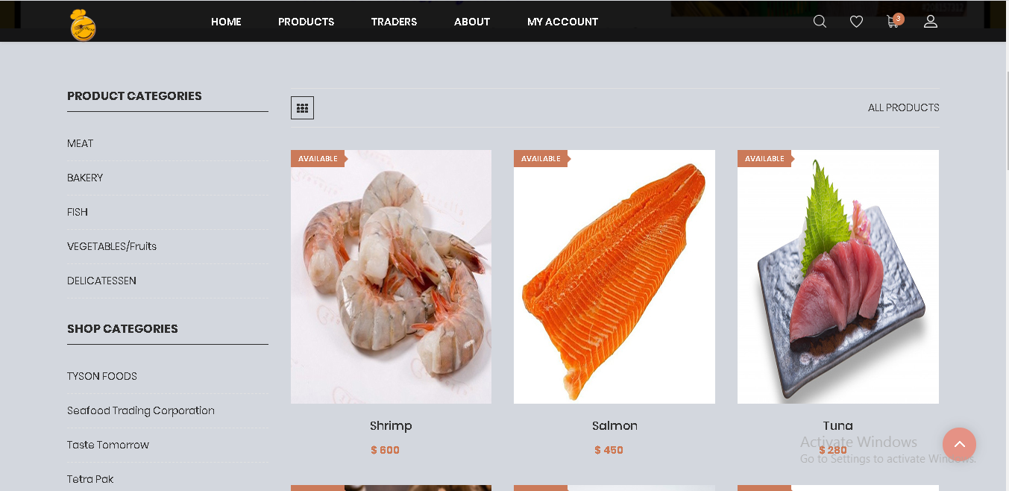

20. After clicking Search icon in the navigation bar you are redirect to search page where you can search any products of your wish

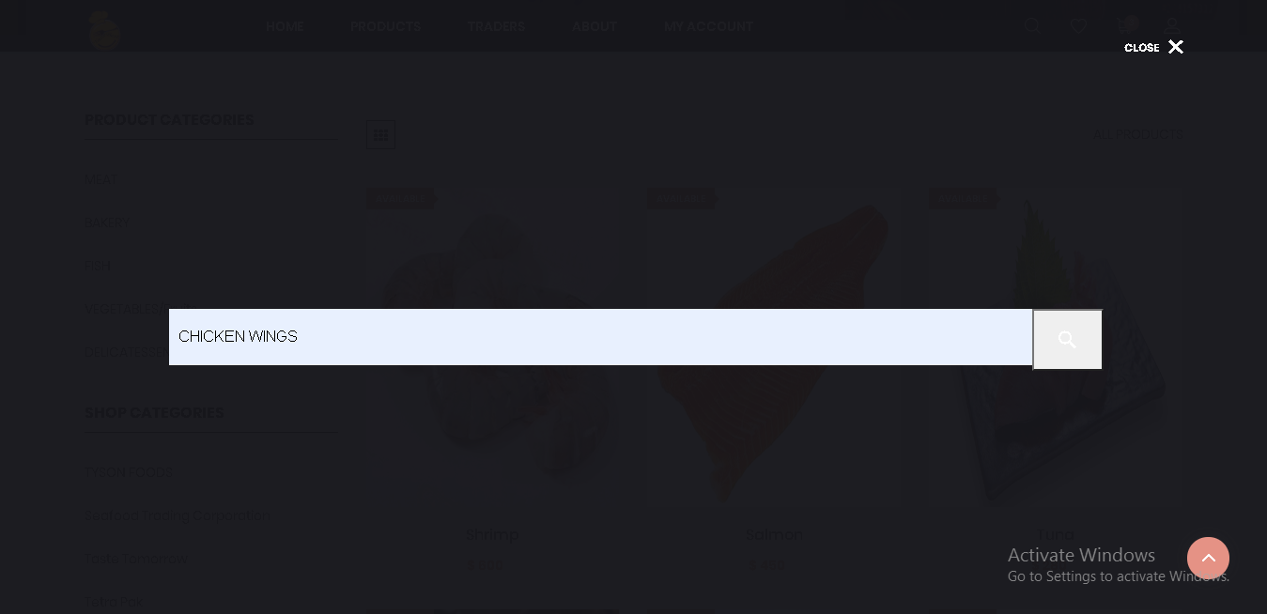

21. When you click on search icon you can view and buy the product you search i.e. Chicken Wings

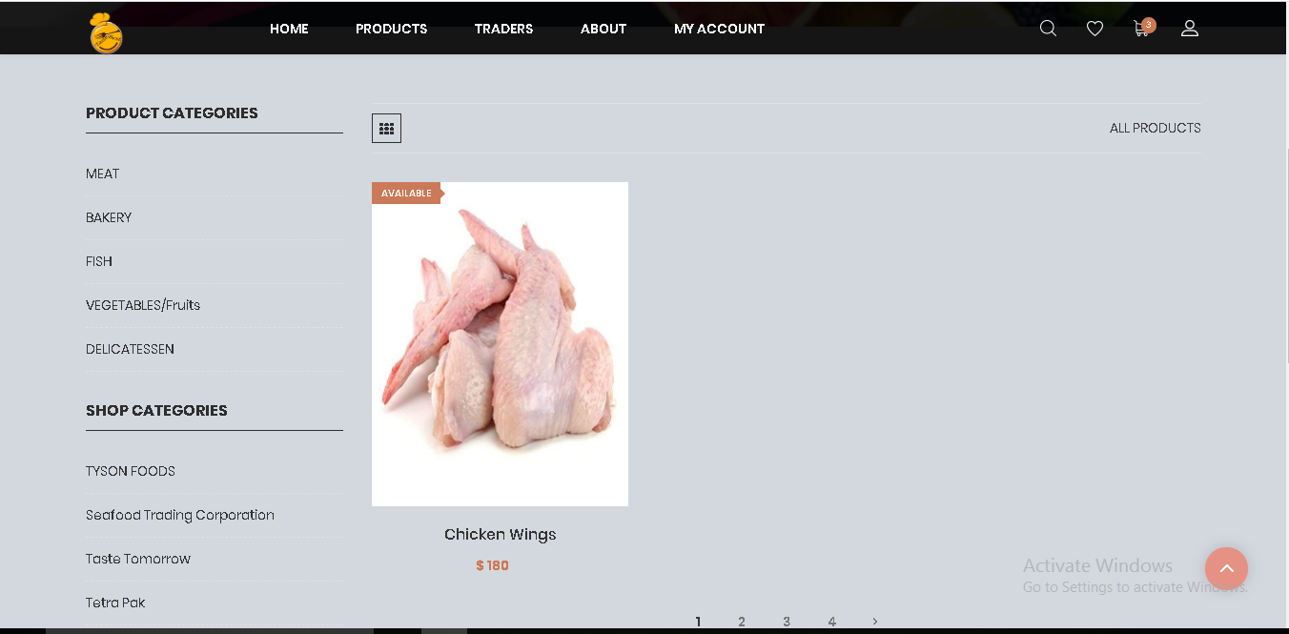

22. When you hover over product in product page two buttons are available add to cart and wish list

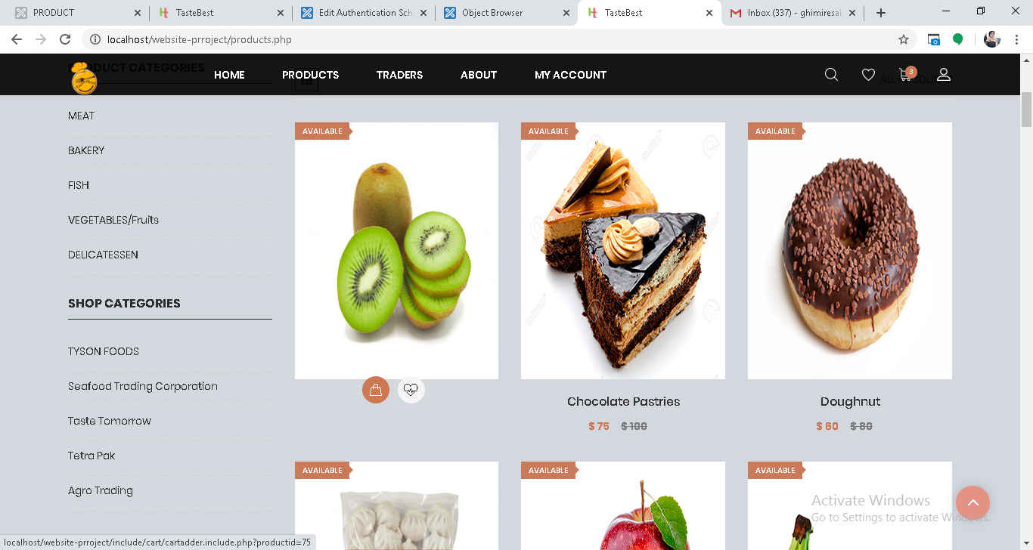

23. Add to Cart

When you click on add to cart icon, you can add product to cart and receive message that shows product have been added to cart in cart page

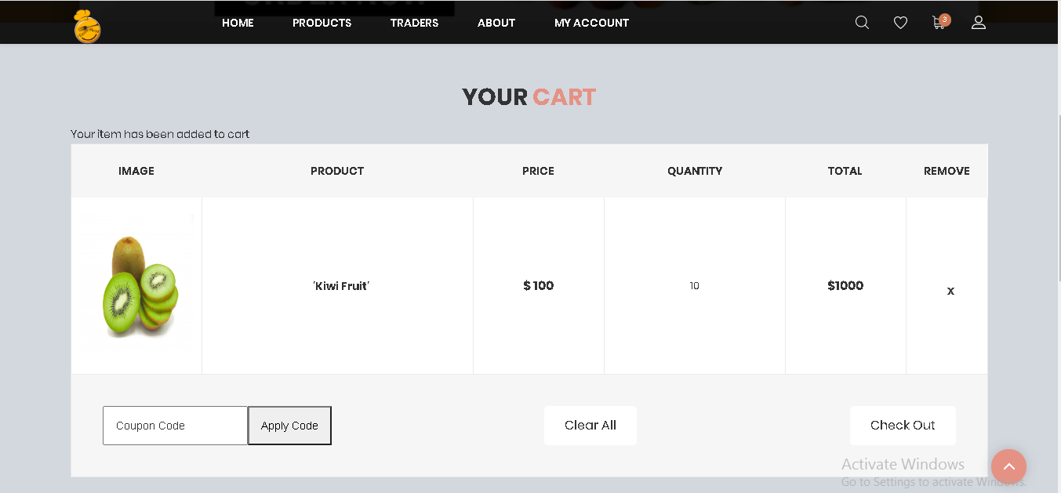

24. When you click on add to wish list icon, you can add Product to your and receive message bar that shows product have been added to wish list and you can view that product in wish list.

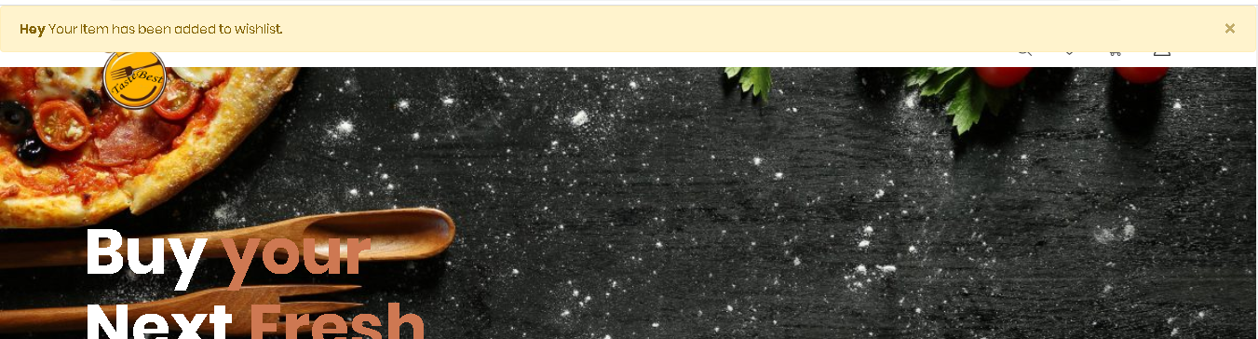

25. When you click wish list icon on navigation bar you can view your wish list.

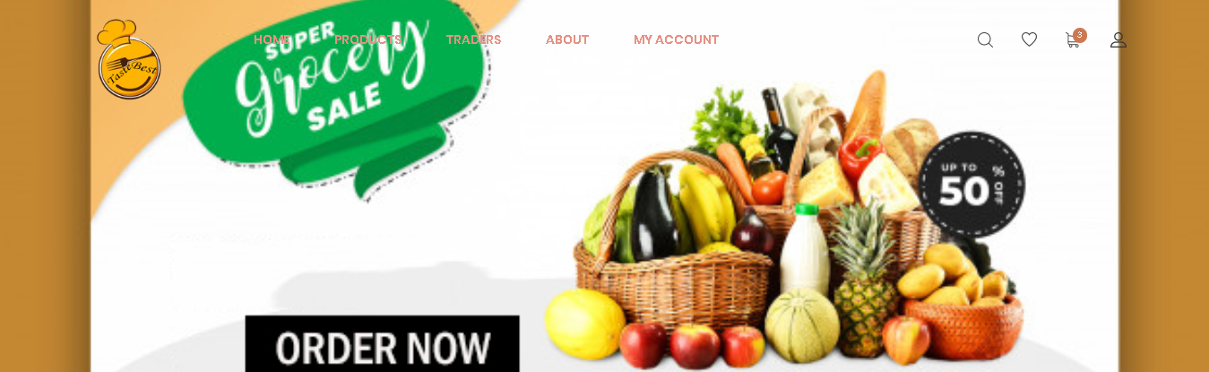

26. After you click on wish list icon you are redirect to wish list page.

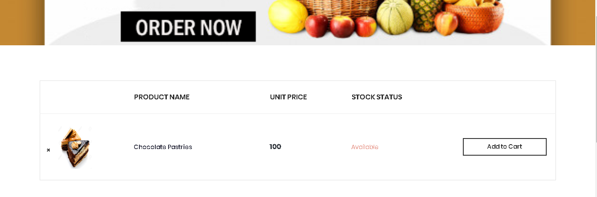

27. When you click on x in the wish list product will be deleted from your wish list and you receive message box that show wish list item has been deleted.

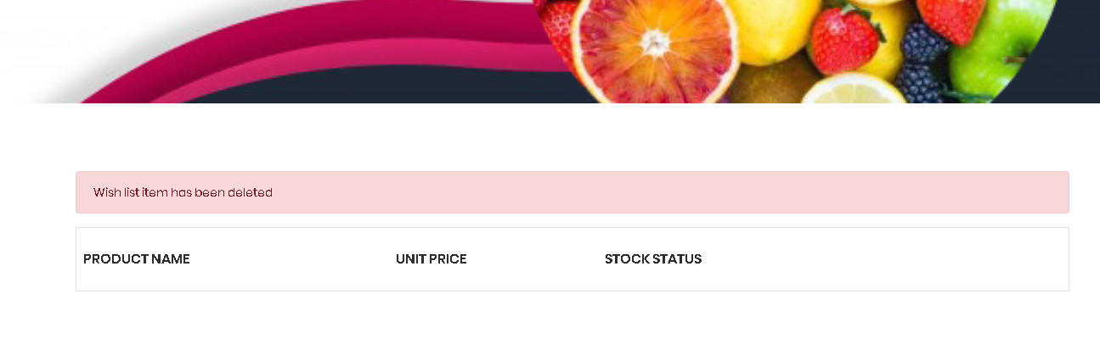

28. When you click on the product image, you are redirect to single product page and view details of product. Single product provides you with product price, product description, allergy information, quantity and other details. When you press on add to cart button you are redirect to cart page.

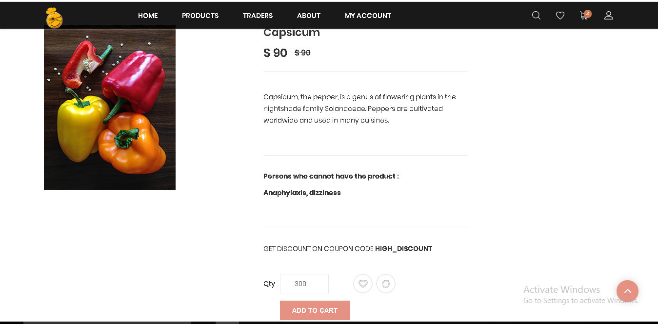

29. After pressing add to cart button you are redirect to cart page and throws the message that item has been added to cart.

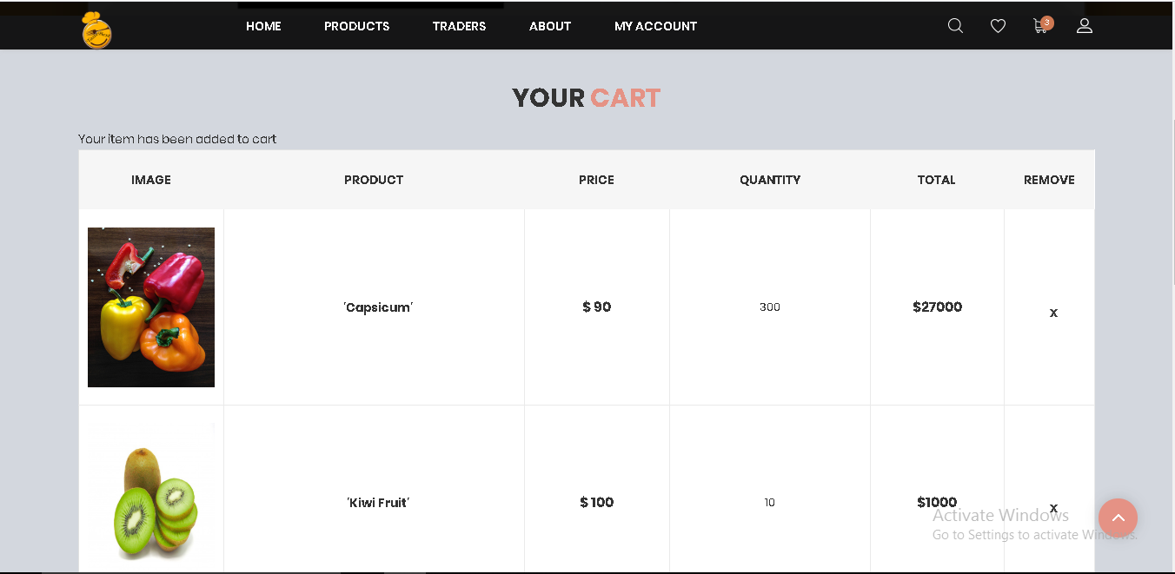

30. If you click on product name, you can go back to single product page and increase quantity.

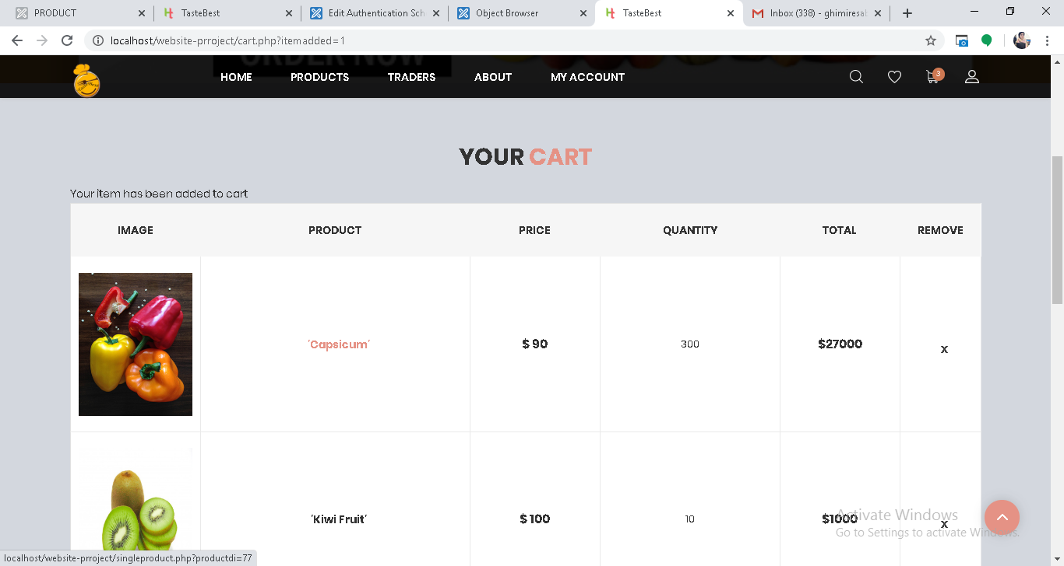

31. Increase the product quantity from 300 to 400 and to cart.

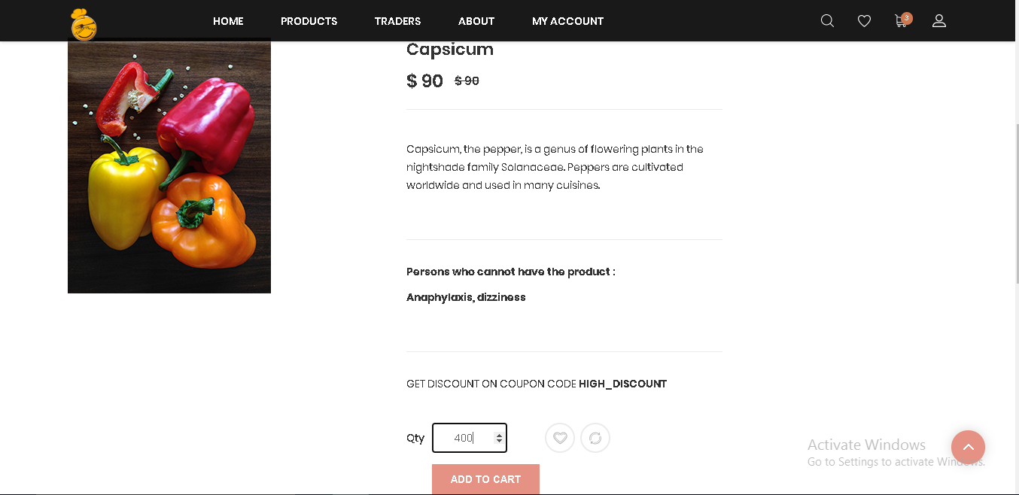

31. After increasing quantity and adding item to cart you get the message revealing you “Your item was already on the cart but the quantity is updated” and quantity raise to 400.

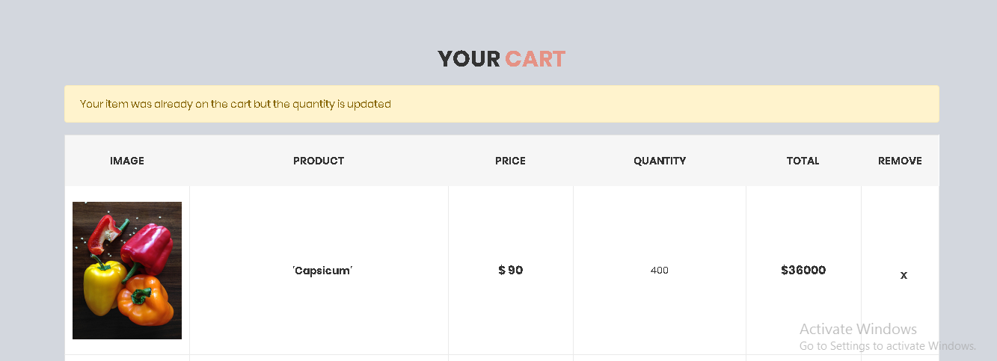

32. Click on x to remove item form the cart and you will get message box that shows Your item has been removed.

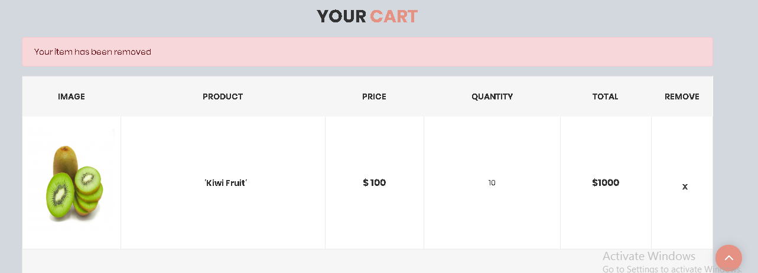

33. Click on clear all to remove every items from the cart, apply coupon code to get discount and cart total, discount and grand total are also embedded in the cart.

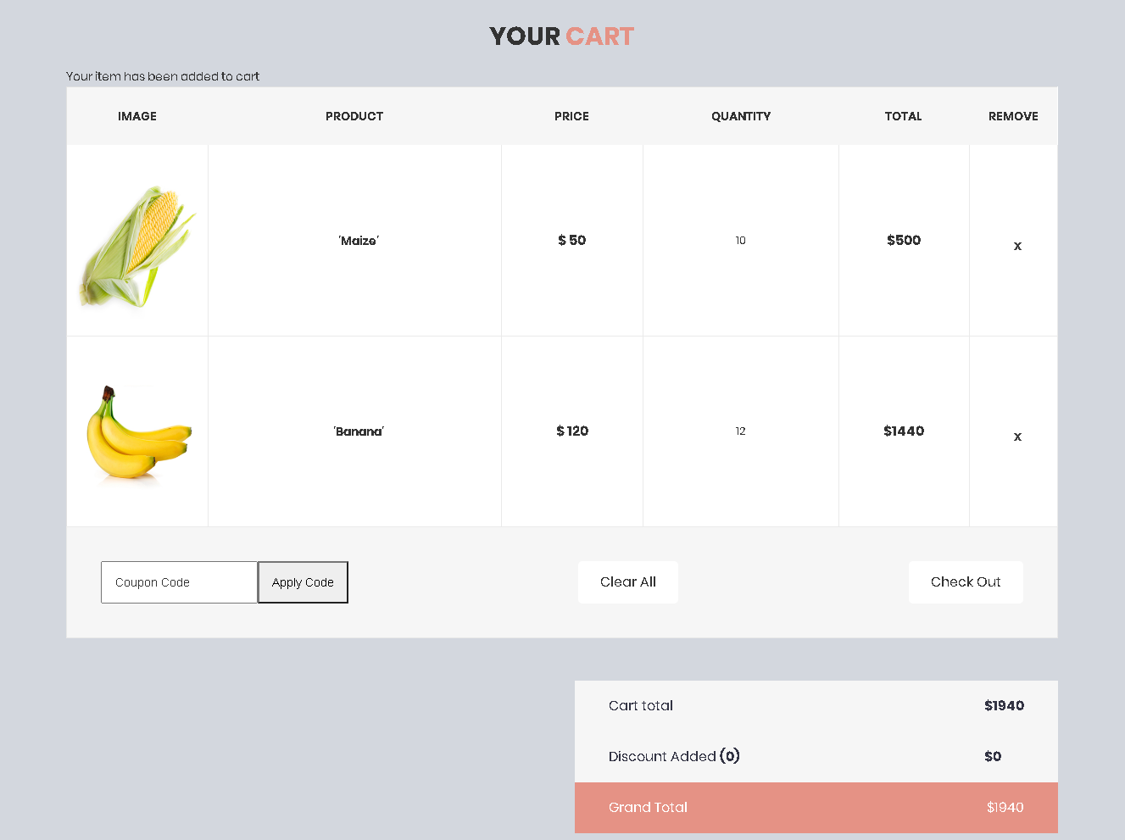

34. When you apply for coupon code discount, discount will be added.

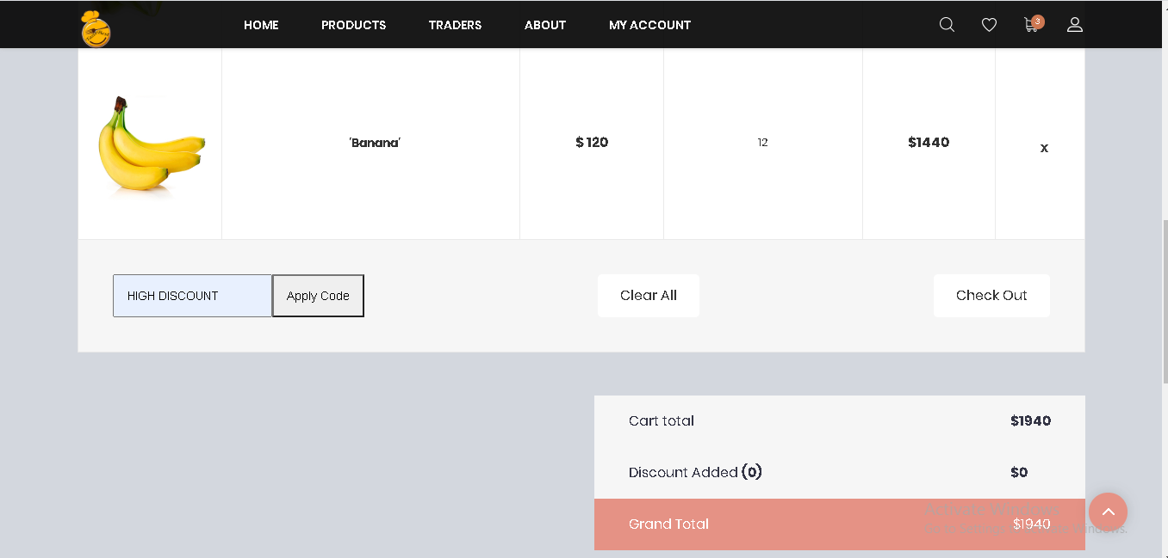

35. After you press apply code, high discount will be added. Same way you can apply for other coupon code discount name.

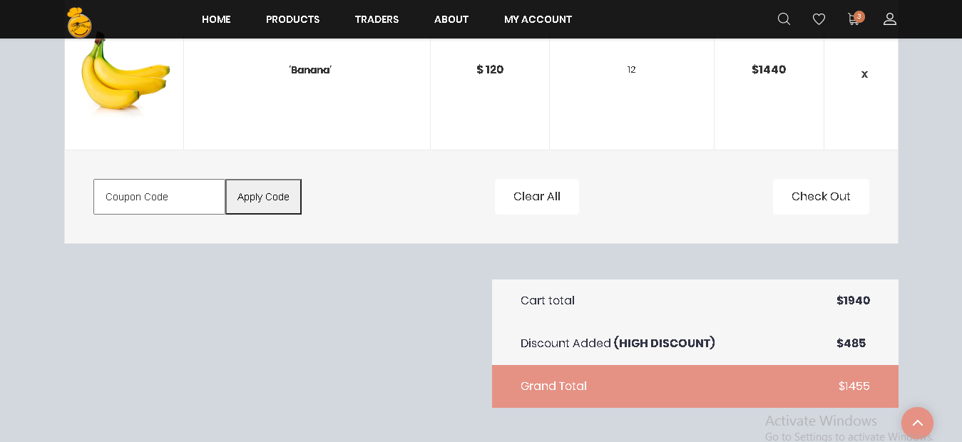

36. In case of invalid coupon code name, then you will get the message showing invalid discount name.

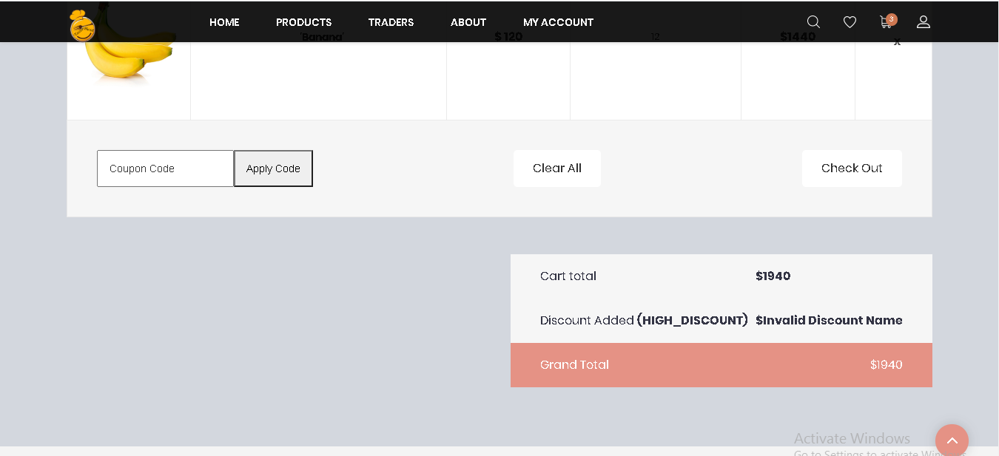

37. Press clear all button to remove all items and you will get message you item has been removed.

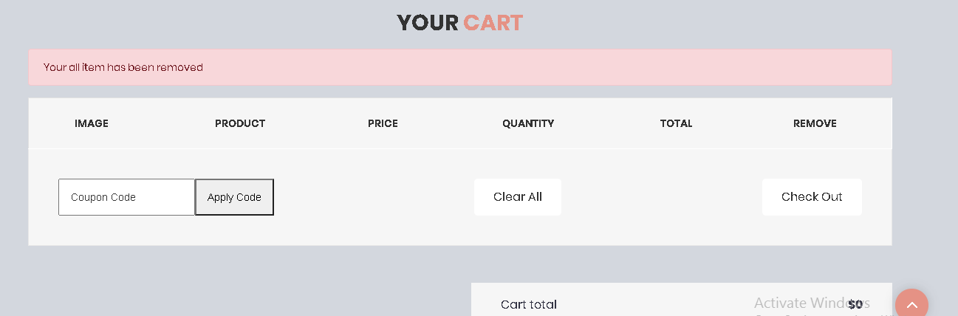

38. Addition of product that is already in the cart shows you message box, telling products has been already added to cart.

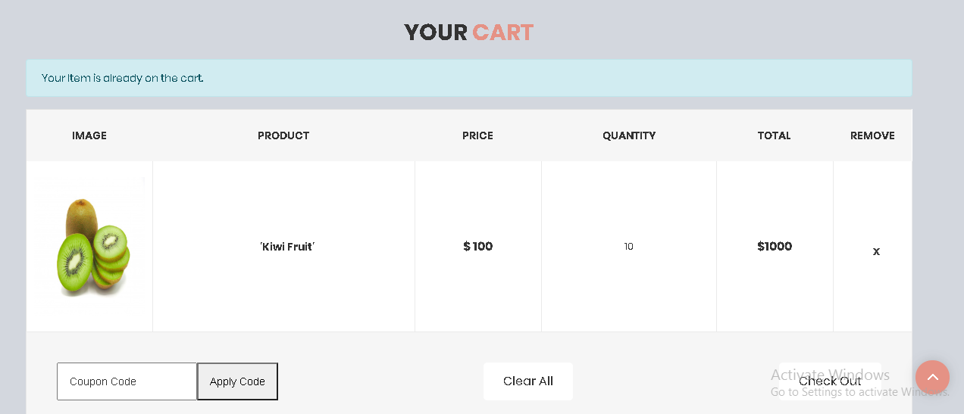

39. Review and Rating is available in single product page, where you can go by clicking on product image. Review and rating by other customer.

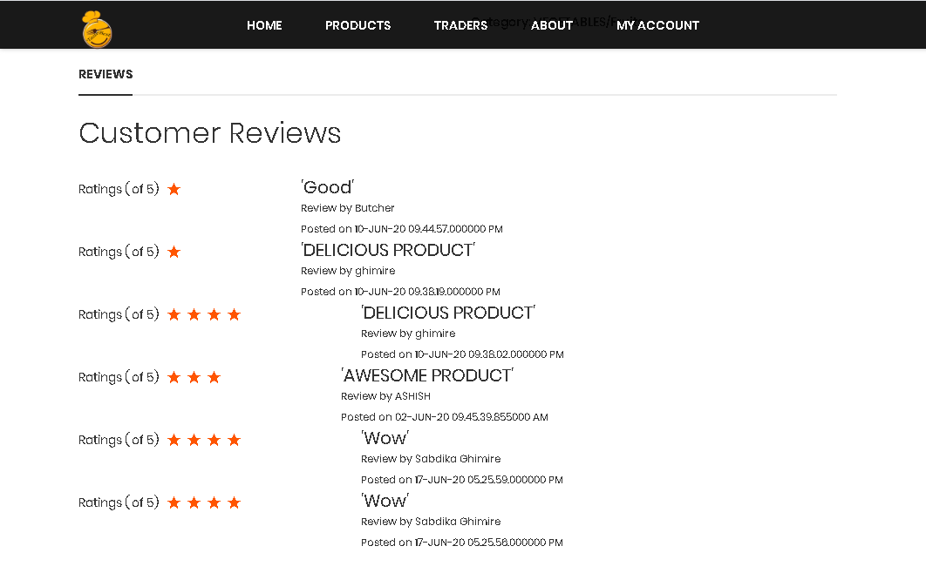

40. You can review and rate the product using review and rating form.

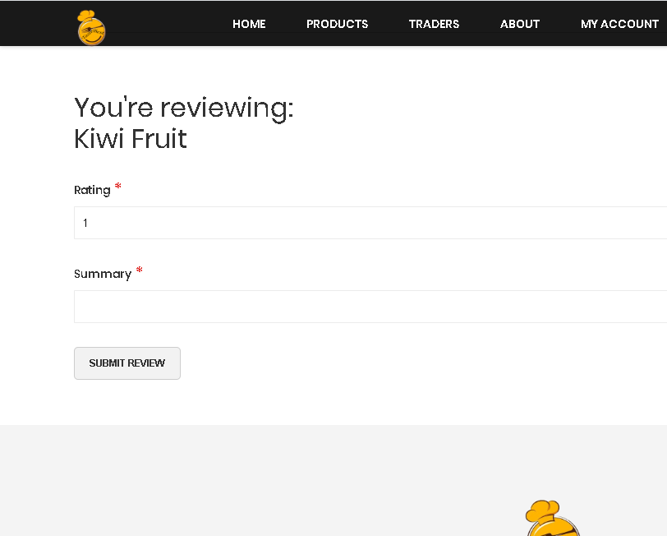

41. After addition of product in the cart, you can proceed for checkout and place the order selecting respective collection slot day and time.

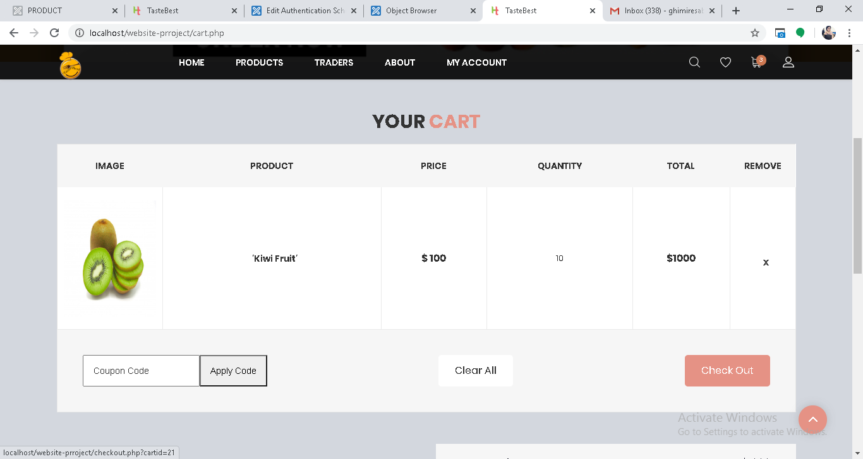

42. Click on checkout button to place the order with respective collection slot day and time.

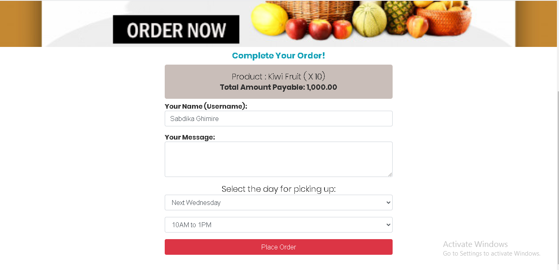

43. Click on place order button to proceed payment via PayPal.

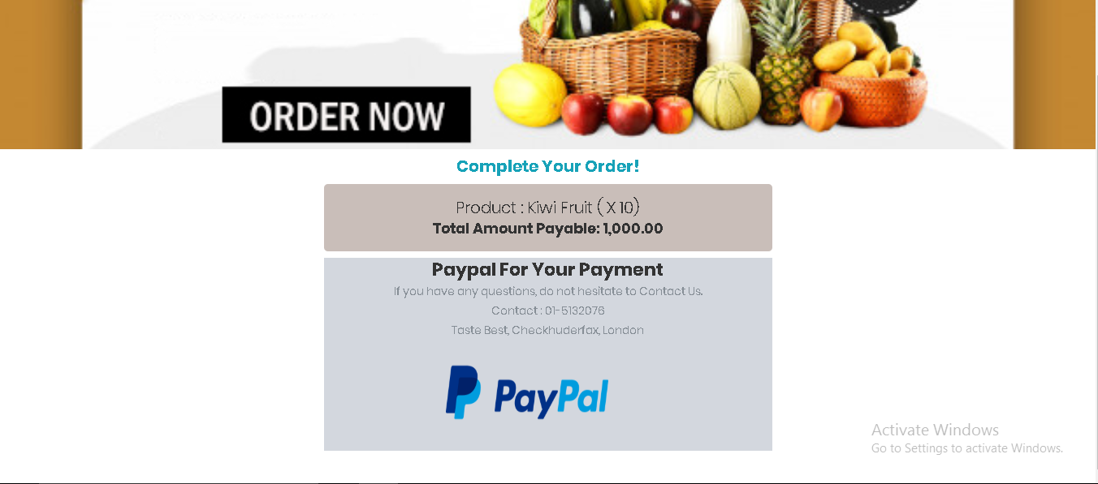

44. For payment click on PayPal and you will be redirect to PayPal login page.

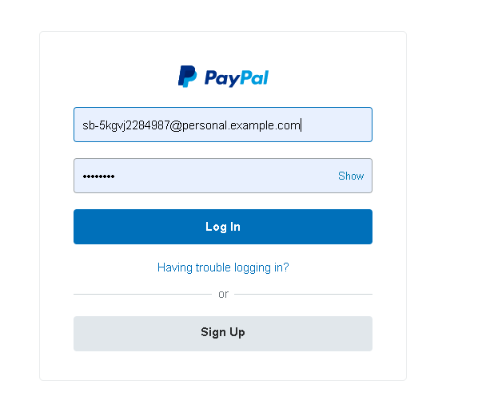

45. Press pay now

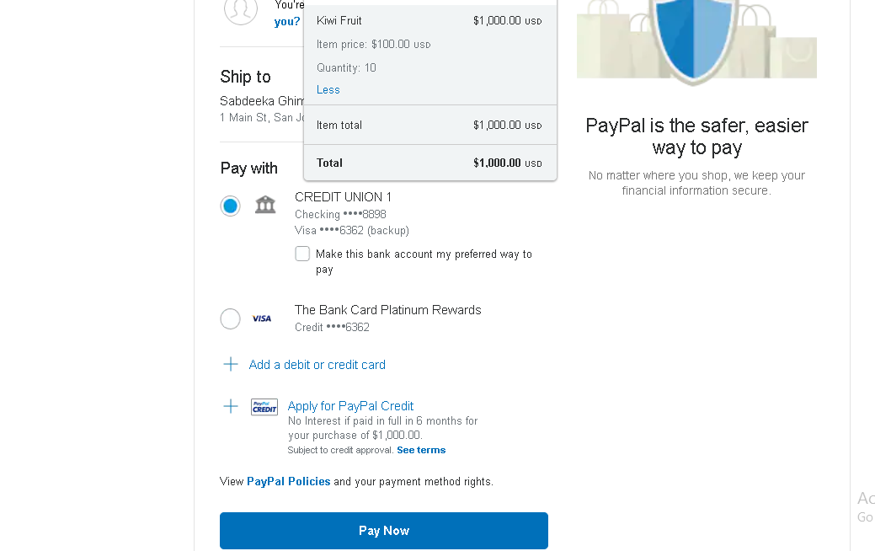

46. When you click on pay now your order will………………….

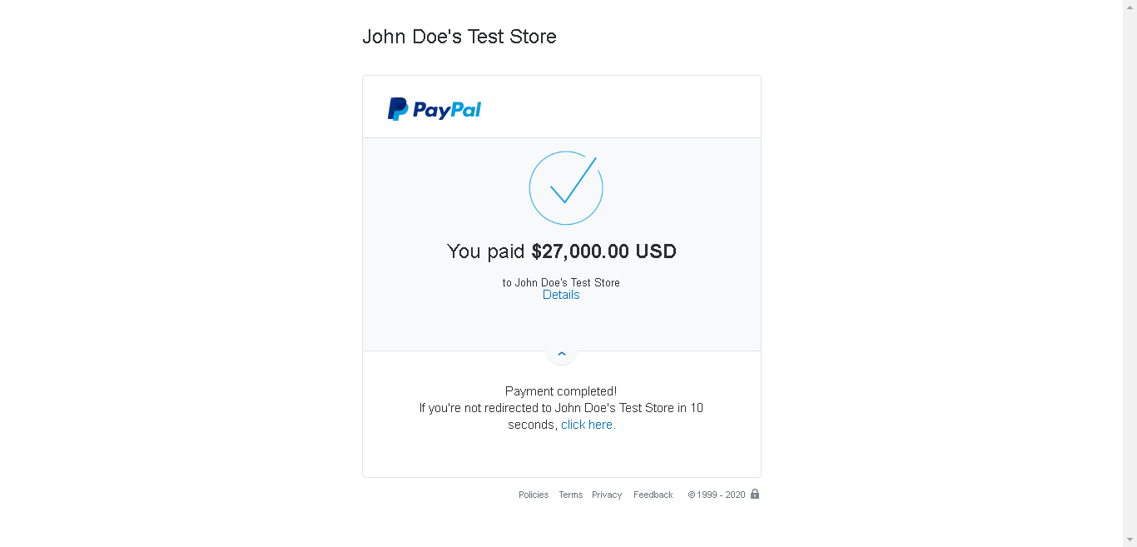

47. Completion of Payment, order will be placed, and you will receive the invoice. Similarly, after payment items from cart will be removed.

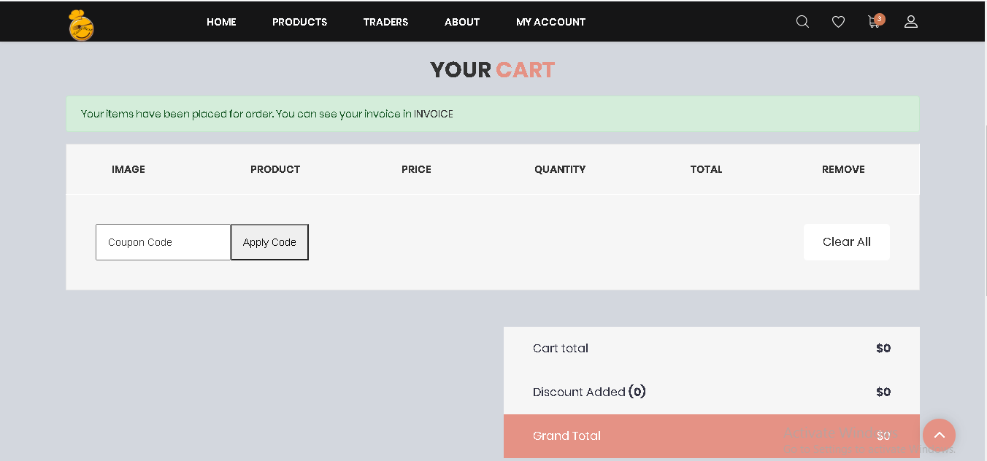

48. My Account Page in the website helps to edit your profile, deactivate your account, and view your order and logout from the website.

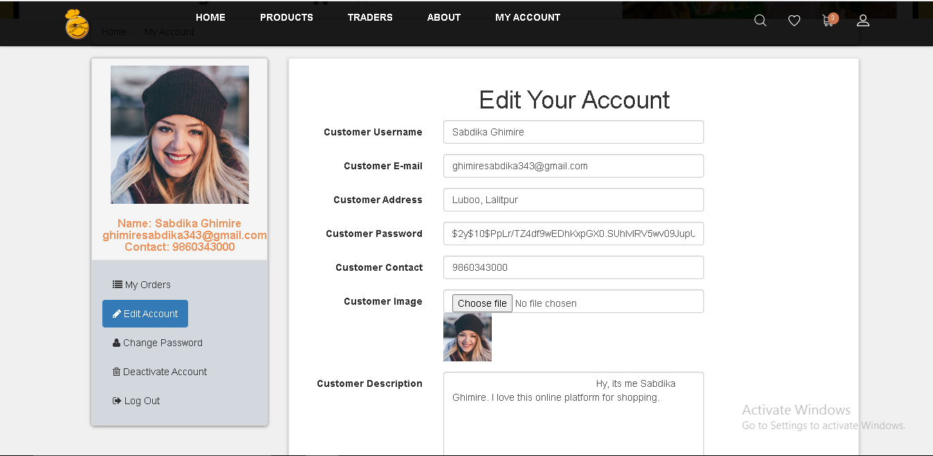

49. When you want to edit your profile you should update the form below.

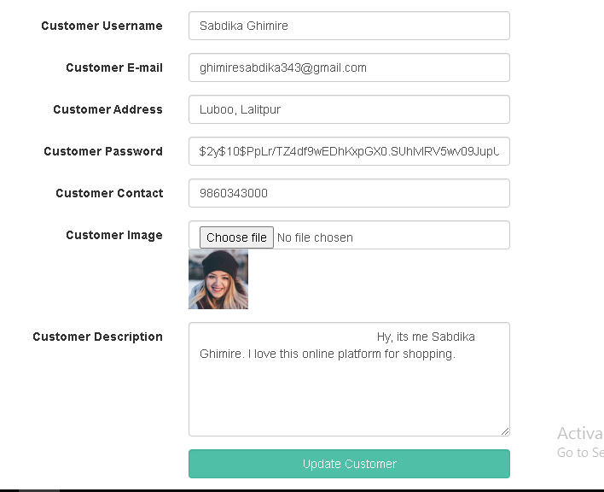

50. After submission of edit account form you will get alert box with your account has been updated message. And when you click ok you will be redirect to login page.

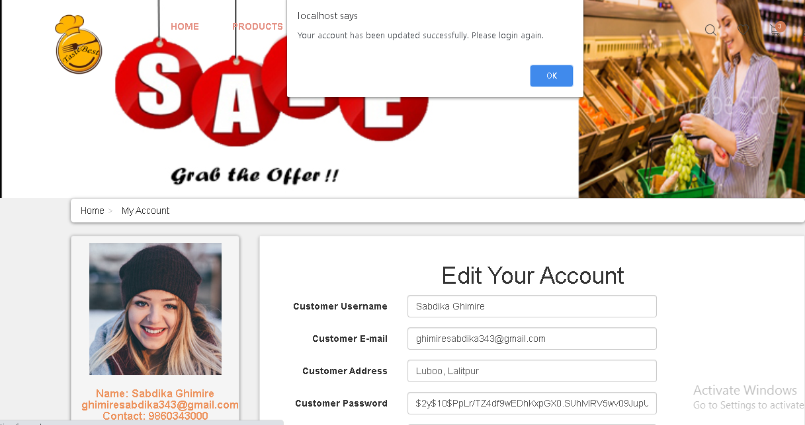

51. To view your order press my order on the side bar of my account page. You can view your order details along with product name and collection slot detail i.e. pick up time and day.

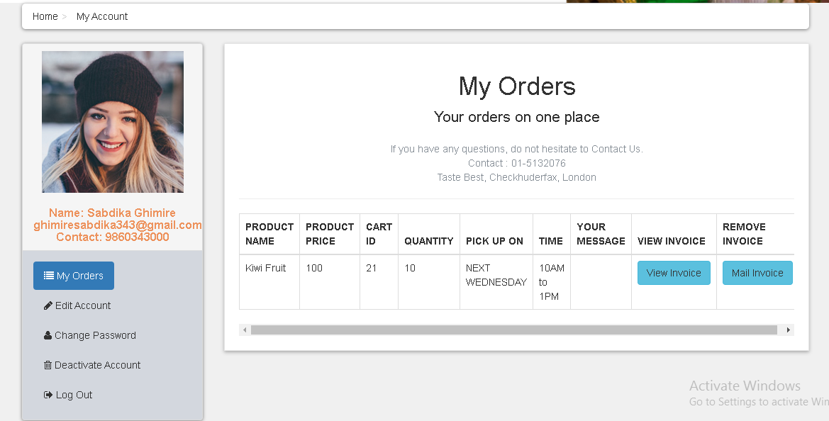

52. When you press on view invoice button, you can view you invoice details. Click on print to print your invoice.

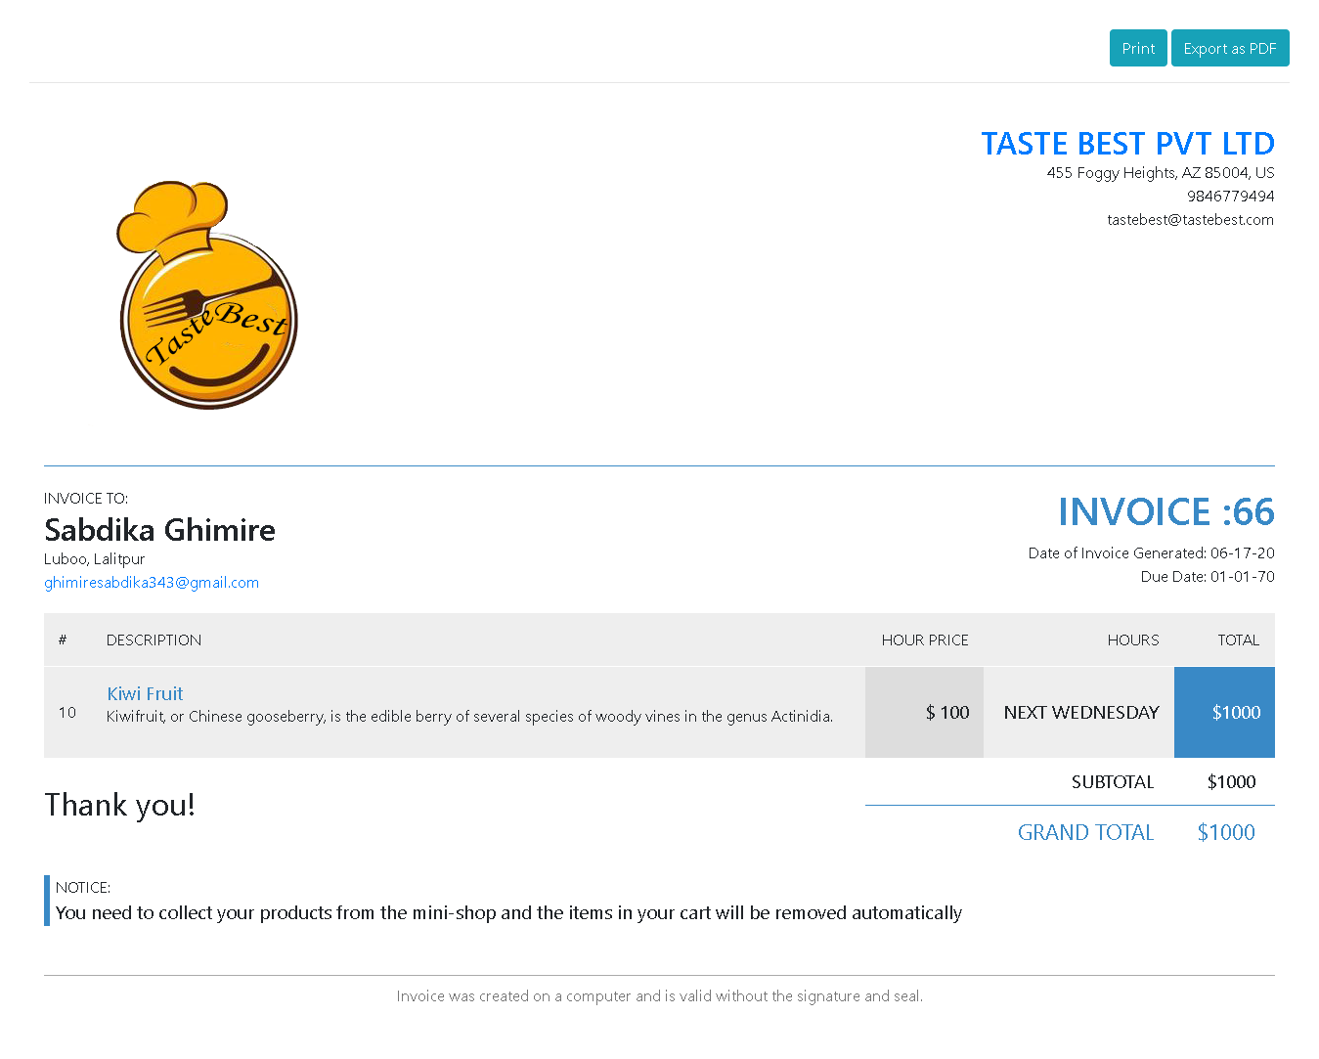

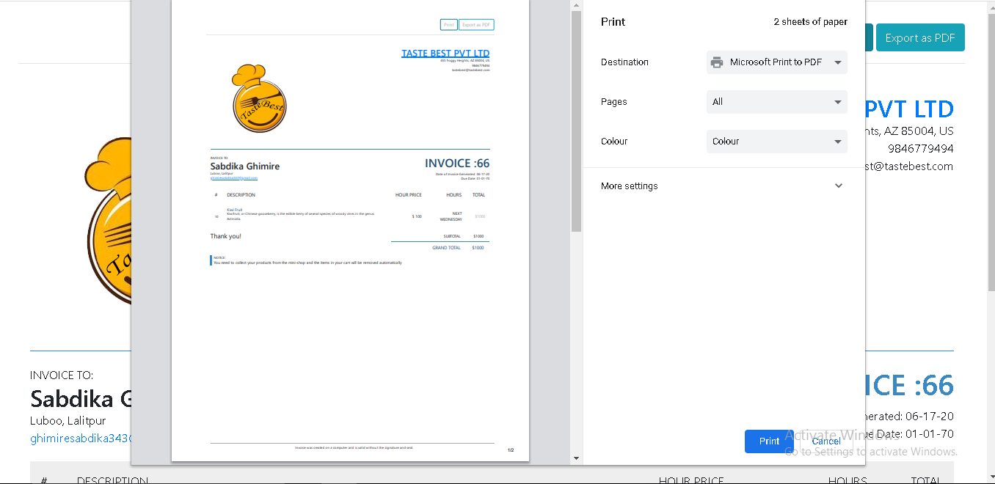

53. Click on remove invoice to remove all of your order details. None of your order will be there.

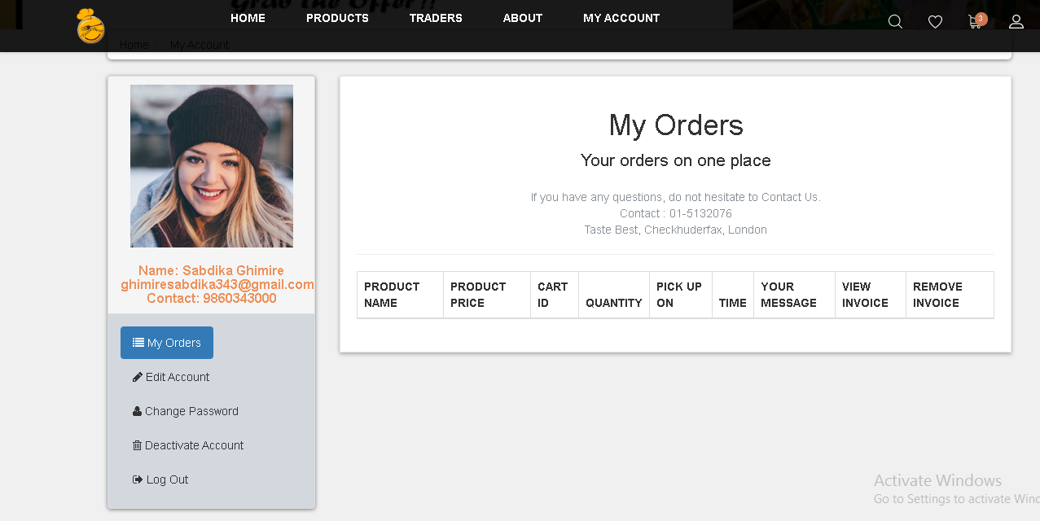

54. If you product in the cart reach more than 20 you can’t proceed for checkout and cant place order with respective collection slot and won’t be able to make payment.

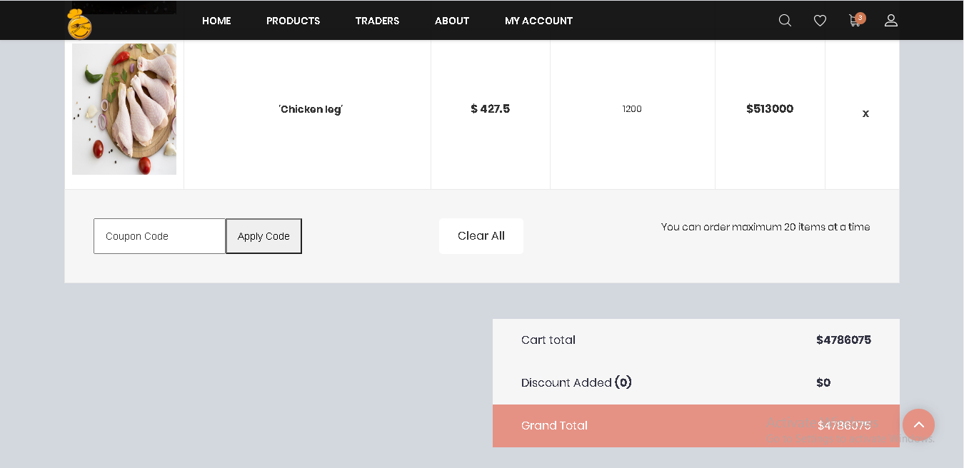

55. Click on deactivate account my account page to deactivate account.

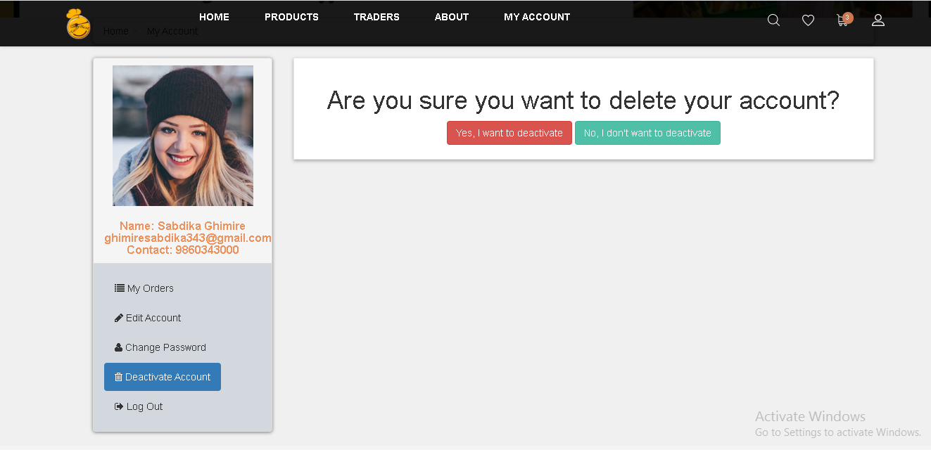

56. Press Yes I want to deactivate account to deactivate your account. Then you will be redirect to login page and to activate your account login again and you will receive OTP verification. After you click on activate button your account will be activated again.

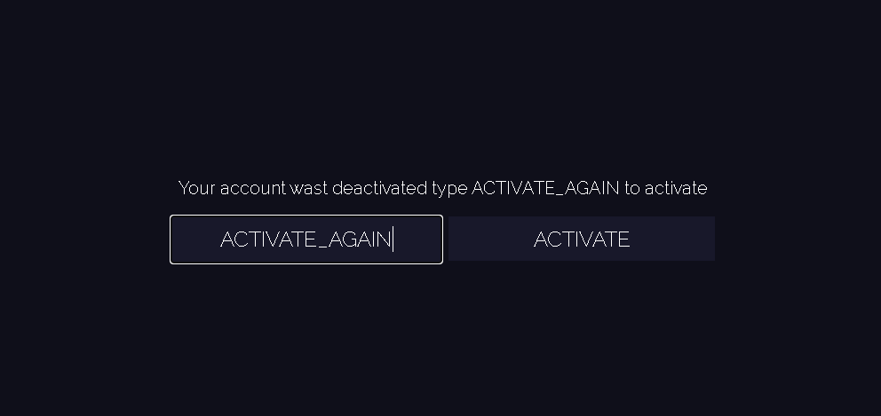

57. To know more about trader click on trader page.

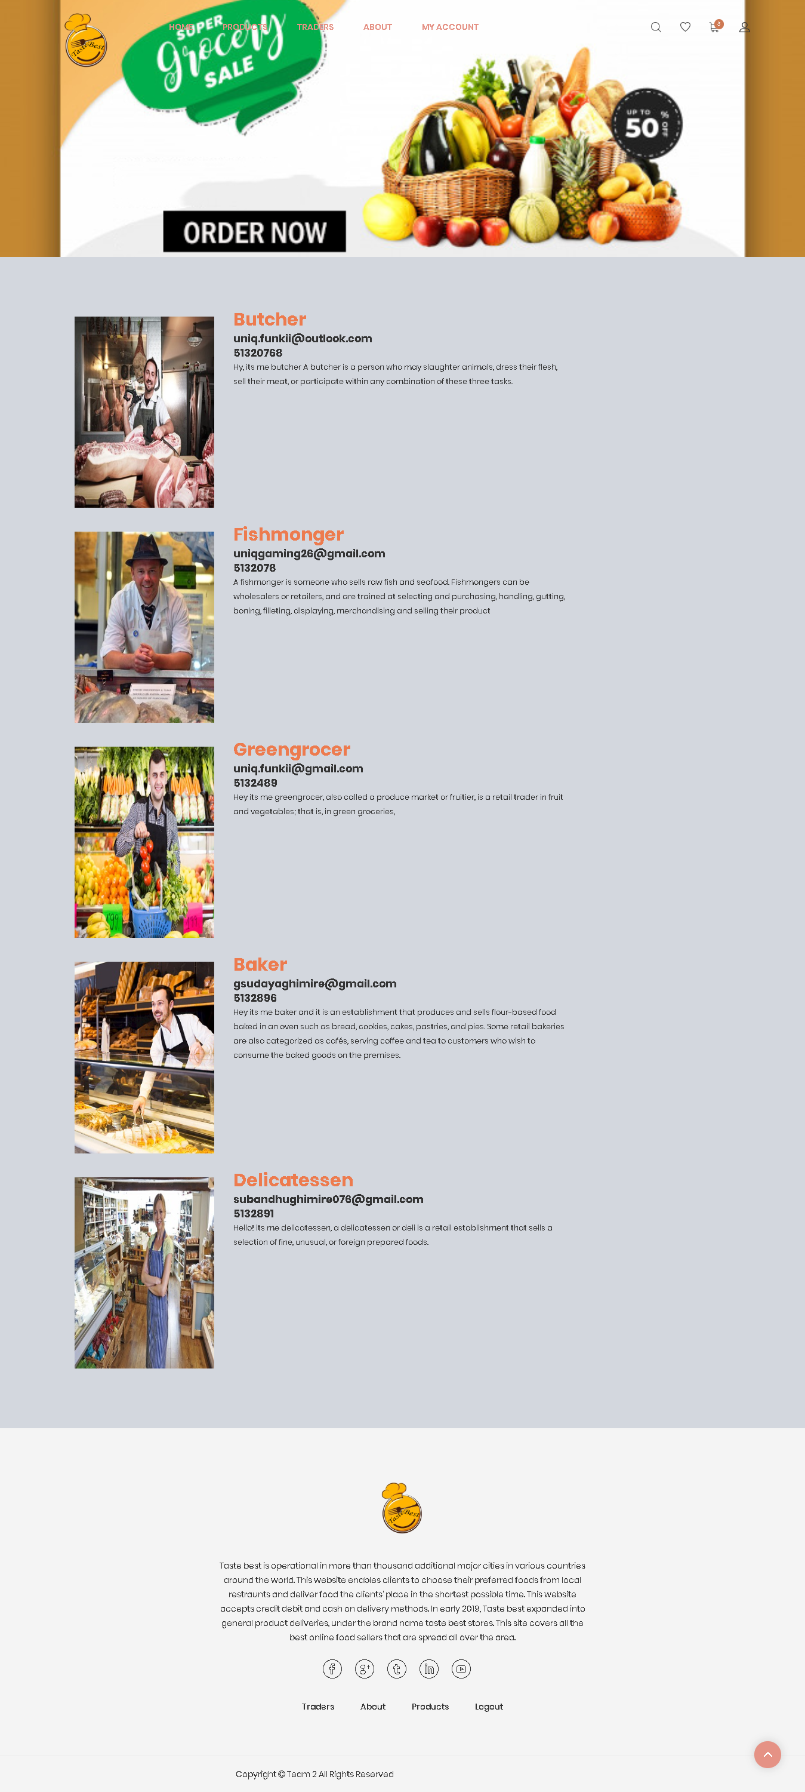

58. Click on about page to know more about our website.

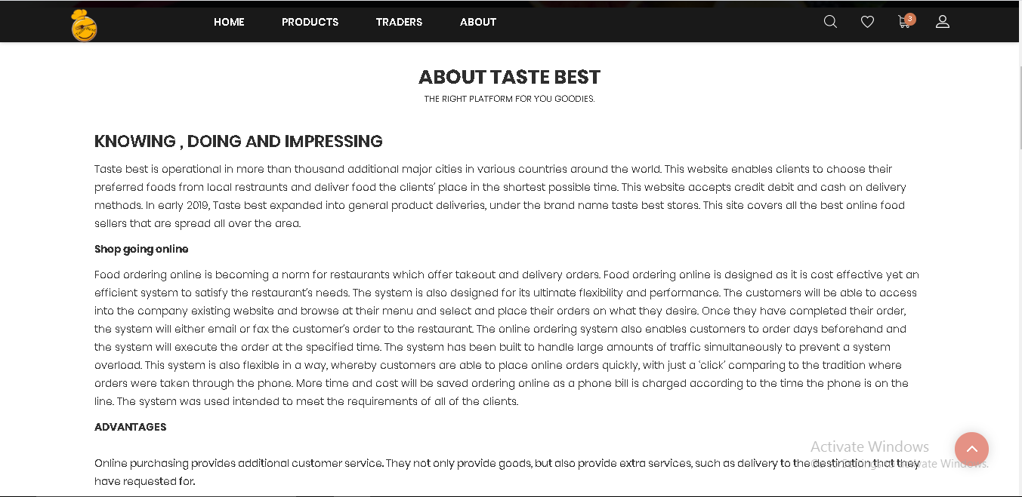



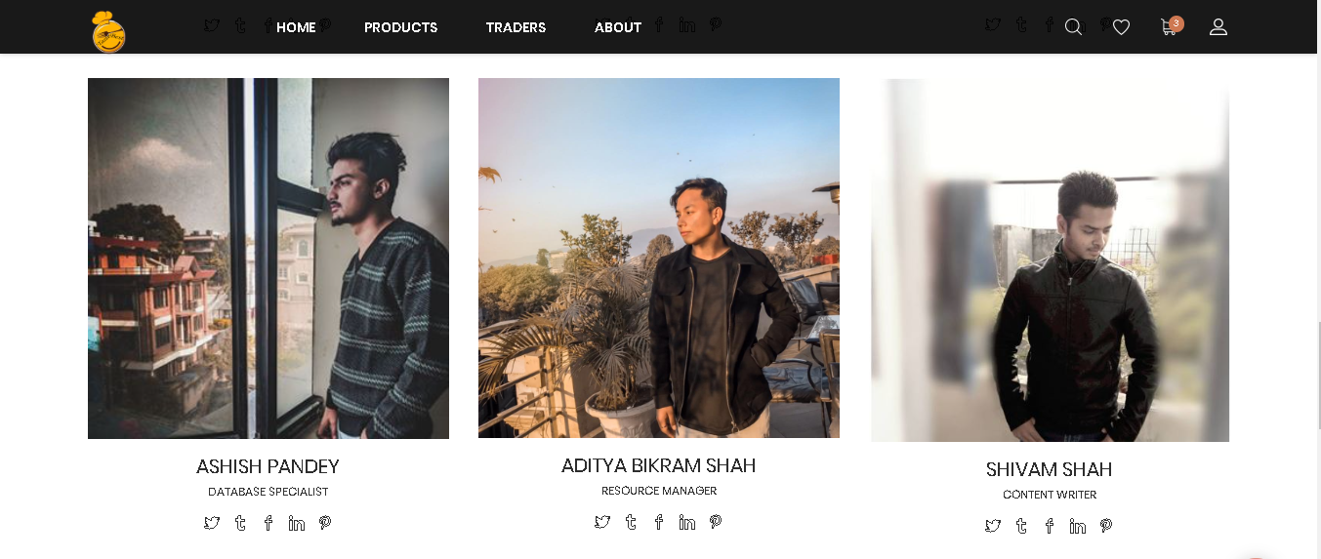

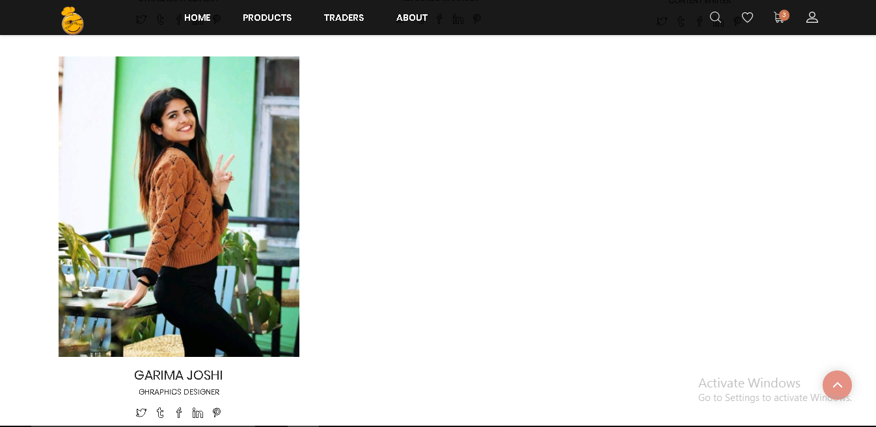

59. Click Logout to go out of website.

